Appendix 1
21/00792/FUL 75 Headley Way
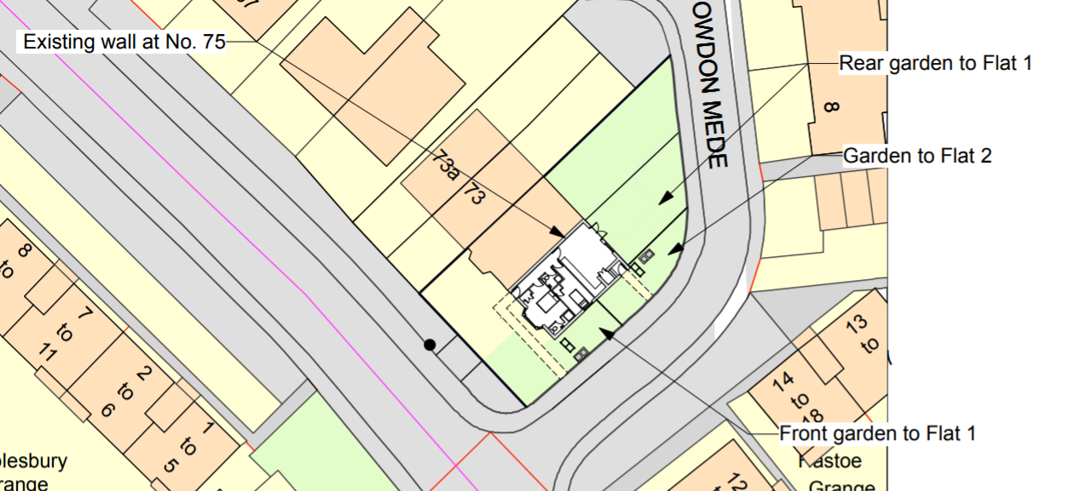
Proposed block plan

